**Group Project 2**

**Goal:** Determine the speed that Twin 1 needs to hit Twin 2 at to stick to each other, and how fast Tiffany will go after the Twins impact her. Also determine the force the end boards will apply on them as they move around the curve.

**Facts:**

* Twin 1 has to have at least 4000J of energy when they collide with Twin 2
* Twin 1 can only adhere to one object that is at the front of their cart
* Wall will guide the two carts together after the first collision
* Width of skating rink: 26 m
* Radius of the curved portion: 13m
* Twins will not be able to increase their speed after the collision

**Lacking:**

* Mass of the bumper carts with passengers
* Velocity of twin 1 at collision
* Velocity of Tiffany after collision 2
* Force end boards on curved section apply to the Twins

**Assumptions:**

* We are assuming no friction
* Collisions are elastic; no energy is lost as heat or sound
* Twins and Tiffany are all the same mass and the carts they use are the same mass
* The total mass of the cart and each person is 200 kg
* The final velocity of twins after collision 2 is 0, all energy is transferred to Tiffany
* Assume the least amount of energy the twins would need for collisions: 4000 J
* Assume that curve is perfectly circular
* Walls are perfectly smooth
* The carts will be treated as point masses

**Equations:**

$∆E_{sys}=W_{surr}+Q$ $E_{e}=\frac{1}{2}K_{s}{(S_{f}-S_{i})}^{2}$

$E_{K}=\frac{1}{2}m{\vec{v}}^{2}$ ${∆E}_{K}=\vec{F}d$

$F_{net, ⊥}=\frac{m{\vec{v}}^{2}}{R}$ $\frac{∆\vec{p}}{∆\vec{v}}={\vec{F}}_{net}$

$$m_{1}{\vec{v}}_{1}+m_{2}{\vec{v}}_{2}=\left(m_{1}+m_{2}\right)\vec{v}$$

**Representation:**

Figure 1

**

Figure 2

**Justification of Assumptions:**

* They are on a skating rink, so there will be no friction between the carts and the ice; we are also assuming that there will be no friction between the wall and the carts to make the calculations simple, as we don’t know a coefficient of friction.
* We assume collisions are elastic and no energy is lost as heat or sound because we don’t know how to calculate these amounts, so we treat both collisions as though energy is conserved, meaning that we can use conservation of momentum principles too.
* Since we don’t know the masses exactly, this assumption will simplify the problem and let us cancel out the masses when working with equations.
* Assuming the mass of the cart and person together is useful for finding exact values. These reflect average values of the mass of humans and the mass of a bumper cart.
* Assuming that all energy transfers to Tiffany during the Twins collision allows for use of conservation of energy and simplifies the problem-solving process.
* With assuming the twins will collide at 4000 J, no more no less, this allows for ease of calculation and that the adhesive will work no matter what.
* We assume that the ice rink has perfectly circular ends and that the boards are perfectly smooth so that we could create a reasonable model that we would be able to solve with our current physics equations.

**Plan of Approach:**

1. Find the speed that Twin 1 needs to collide with Twin 2 at.
   * Use Kinetic energy equation and the energy it needs which is 4000J
2. Find the speed of the Twins when stuck together.
   * Use conservation of momentum
3. Find speed of Tiffany after collision with twins.
   * Use conservation of momentum
4. Draw net force diagram for the midpoint of the curve.
5. Find Fnet at the midpoint of the curve.
   * Use Fucm equation with velocity found in step 2

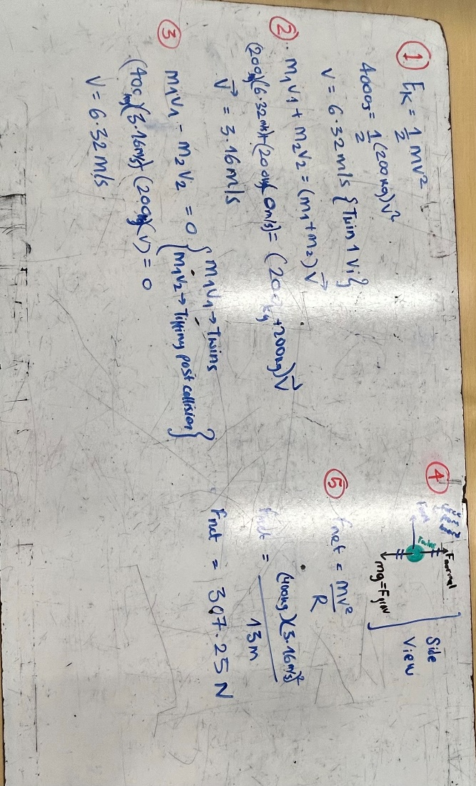**Calculation w/ Explanation:**

1. Using the kinetic energy equation, we plugged in 4000 for the energy, 200 for the mass, and an unknown velocity. We solved for v to find that the speed of twin 1 right before collision 1 was 6.32 m/s. We used 4000 for the energy because that was the minimum energy that twin 1 had to collide with twin 2 at.
2. We used the conservation of momentum equation for objects that stick together after the collision to find what speed the twins would have after collision 1. We treated twin one as m1v1 and twin 2 as m2v2. Since twin 2 originally had a velocity of 0 m/s, the equation shows the mass of twin 1 times the velocity of twin 1 the instant before the collision set equal to both twins masses added together multiplied by the final velocity. The final velocity value represents the speed of the twins together.
3. We assumed that all of the energy from the twins was transferred to Tiffany. The mass of the twins together is represented by m1, and the twins’ speed before the collision is represented by v1. The mass of Tiffany was represented by m2, and her final speed after the collision was represented by v2. Since Tiffany started at rest, the only velocity she has in the equation is v2. We found her final speed after the collision to be 6.32 m/s.
4. This is the net force diagram for the twins going around the turn, specifically when they are in the center of the curve, as represented under the representations part of the board. The only forces acting on the twins in this instant are the force of gravity, the normal force, and the centripetal force. The force of gravity and the normal force balance each other out, since the twins are not accelerating up or down, which means that the net force acting upon the object is the centripetal force.
5. This step calculates the net force discussed above. Since the twins’ carts are experiencing uniform circular motion at this point in the curve, we can use the perpendicular net force equation. We took the radius to be 13m, half of the width of the rink. We found this net force to be 307.25 N.

**Evaluation of Solution:**

* They don’t hit Tiffany with great speed. Average running speed of a human is 5m/s, and they hit Tiffany with 3.16m/s. So, Tiffany wouldn’t have a concussion after the collision which makes sense for a bumper car situation.
* It makes sense that Tiffany would go 6.32 m/s after the collision and the Twins collide with Tiffany at a speed of 3.16 m/s, because the Twins are twice the mass as Tiffany.
* Our units also all make sense; throughout our calculations, the units evaluate to what they should be based off the inputs that we use.
* The force on the twins as they travel around the curve is 307.25 N; the highest force a person can withstand is 3500 N, so this force seems reasonably small, especially considering their small velocity.

**Evaluation of Model:**

* Assuming that there is no friction is very unlike real life. In real life, there is no way the energy would not be lost to the scraping of the cart to the edges of the ring as heat or maybe light.
* A mass of 200 kg can easily go up to 4000 J of kinetic energy as it implies not a super-fast speed.
* Treating the two bumper carts as one big mass that has no internal energy or relative motion is not realistic. We assume the carts are point masses, and in real life, they would have dimensions.
* As a result of the point mass assumption, we get rid of the fact that because of the height and width of the cart, there would be air resistance which would slow down the carts as they approach the curve.
* We assume the curved part of the rink is perfectly circular, and that doesn’t match most of the real-life ice rinks that look more like curved rectangles.
* The friction from the edge boards would slow down the carts, so they wouldn’t be able to keep their velocity constant.
* Because there is Uniform Circular motion at the curved part of the ring, it makes sense that the speed stays the same, as per definition of UCM, the only thing that changes is the direction of the velocity.
* In the second collision between the twins and Tiffany, we assumed that all energy would be transferred from the twins to Tiffany. In real life all energy might not be transferred and while Tiffanys final velocity would still be greater than the twins, the twins final velocity might not be zero.
* We assume the carts are perfectly solid and completely rigid, but bumper carts are usually more squeezy and more elastic, which prevents them from breaking with impact. That detracts from reality.

**Improvements to Model:**

* If we could determine the friction between the boards and the carts, we could determine the velocities of the carts more accurately and the velocities would likely be slower. The boards may also not be perfectly smooth.
* There must also be some friction between the carts and the ice which would slow the carts down by a small amount.
* The bumper carts would not be point masses in real life; instead, we would have to treat them differently as the weight distribution would be different, and since there would be dimension to the cart and person, there would also be air resistance. This would impact our solution by decreasing the velocities of the carts as they travel around the curve, which would decrease the amount of energy that would be transferred to Tiffany’s cart in collision 2.
* We could learn the masses of the people before they get on the bumper carts, and we could weight the carts. This would help us have more precise measurements.
* As a result of the “pillowiness” of the carts and other factors mentioned before like friction, it wouldn’t be realistic that all energy from the twins is transferred to Tiffany, which means that we would not be able to use conservation of momentum. Some of the energy transferred to Tiffany would be lost as heat or sound.
* Since the ice rink most likely wouldn’t be a perfect circle on the edge, we would not be able to assume uniform circular motion, which means that speed likely wouldn’t be conserved throughout the curve of the rink.